SPECIALIZATION AND GENERALIZATION

Let us take an example of a vehicle company who wants to market its products by building a catalogue interface for its customers to view and make their choices. Let the Vehicle Company be called “ABC” motors, with its 3 products:-

1. “QWE” (Light Utility Vehicle):- Having features such as a manual gearbox transmission, power windows, auto key unlocking etc.  
     
   However, under this category, there are further subdivisions based on some additional features such as fog lights, ABS, sun roof etc. Let us assume model R,T and Y exist under this category.
2. “ASD” (Sports Utility Vehicle):- Having basic features such as wider tyres made with specific rubber composites to withstand off-terrain ruggedness, back-wipers, Halon Lights etc.  
     
   However, under this category as well, there are further subdivisions based on some extra features such as over-carriage, sun roof, sports seat trim etc. Let us assume model F,G and H exist under this category.
3. “ZXC” (Sedan):- Having minimal features such as leather seats, rear view camera with parking assist, automatic wiper functioning upon sensing rain etc.  
     
   Under this category, we have further subdivisions based on features such as extended boot space, sun roof, custom body colour etc. Let us assume model V,B and N exist under this category.

The UML model for the above given example would look something like this:-  
 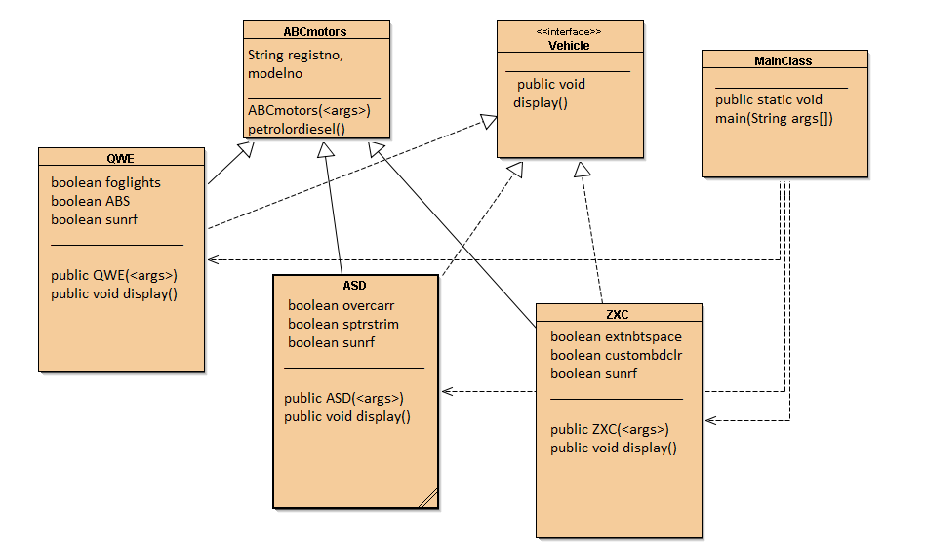

**Specialization**

*“Specialization is defined as the process of subclassing a superclass entity on the basis of some distinguishing characteristic of the entity in the superclass.” [1]*

Considering the above example, we see that features such as foglights, ABS, overcarr etc. are very specific to the model of the car, and don’t exist in every car that is manufactured by ABCmotors. It wouldn’t make sense to put such attributes in the super class and then inherit them, when they won’t be used in the subclasses. This is the general understanding of *Specialization*. It follows a top-down approach.

**Genralization**

“Generalization *is the process of extracting shared characteristics from two or more classes, and combining them into a generalized superclass. Shared characteristics can be attributes, associations, or methods.”[2]*

Let’s dwell on the same example here. The superclass contains resgistno, modelno and petrolordiesel() method. All of these attributes are common to all the subclasses.If one notices, the data attribute Boolean sunrf (sunroof) also exists in all the subclasses. This could be made to exist in the superclass itself, such that all the subclasses are able to access it. This is the general understanding of *Generalization*. It follows a bottom-up approach.

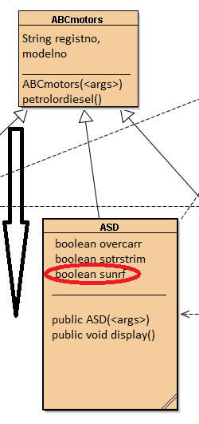 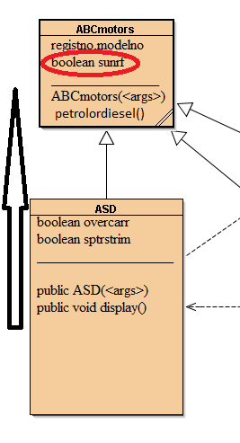

1. Specialization b) Generalization

Output:-

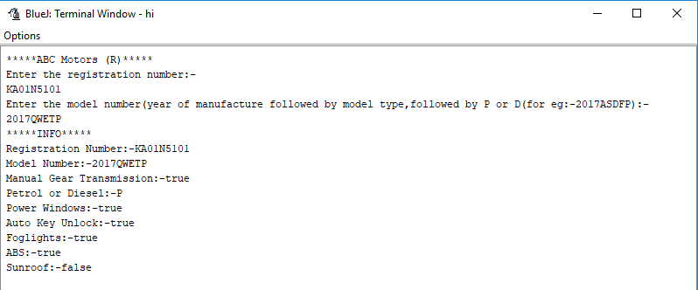

References

1. <https://www.developer.com/java/data/implementing-generalization-and-specialization-in-java.html>
2. <https://sourcemaking.com/uml/modeling-it-systems/structural-view/generalization-specialization-and-inheritance>

*(Please find the JAVA program attached. To execute, navigate to the package, and execute MainClass)*